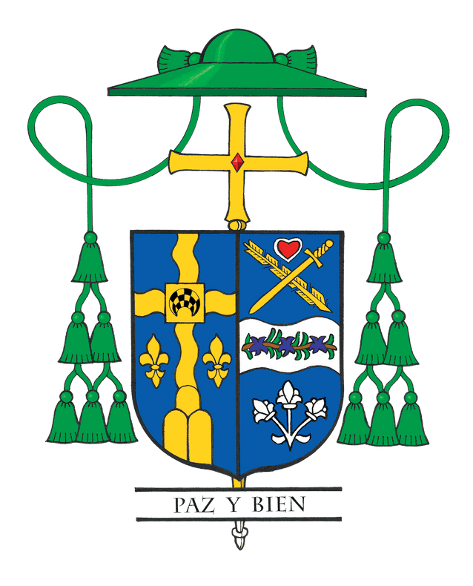
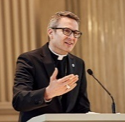
Bishop Hicks’ Column, Dec. 2025

Finding Hope Behind Bars:
Becoming Disciples Who Make Disciples in Unexpected Places

We celebrate Advent and Christmas as seasons of light and joy, yet sometimes the brightest hope appears in the places we least expect. Over the years, I have found that ministering to those in prison is one of the most unexpected ways to live out the call of my pastoral letter MAKE to be disciples who make disciples.
My first encounter with prison ministry goes back to my volunteer year in Mexico in 1989. A female catechist invited me to join her in visiting a large prison. I remember the surprise of walking in with barely any formal checks and feeling a bit baffled and nervous about how I would get out. Yet what stayed with me most was her simple reminder: “They all have names. They are often forgotten, but if you become a priest, remember they exist. See the face of Christ in them!”
Years later, as a seminarian accompanying Cardinal Bernardin to the Cook County Jail for Christmas Mass, I saw that same spirit of discipleship. He had no family in Chicago, yet he found joy in bringing the Eucharist to those often forgotten. He showed me that prison ministry is not simply a duty but a moment of grace. It is a chance to be a disciple who brings Christ’s hope to others.
Someone once told me that one of the humbling aspects of ministering in prisons is that the people you serve can never repay you. You do it simply because Christ calls us to recognize His presence in them. In that pure act of service, we quietly plant seeds of faith in hearts that society often overlooks.
Two weeks ago, I had the privilege of celebrating the Sacraments of Baptism, Confirmation, and First Holy Communion for four inmates at the Joliet Detention Center. Their deep desire and reverence reminded me again of that woman’s wisdom from years ago. They have names, they exist, and they are just as worthy of God’s grace. After the Mass, each newly minted Catholic offered a testimonial, thanking those
who brought Christ to them and sharing how lost they felt before being introduced to God and the Church. Their desire to cling to hope and live out their newfound faith inspired me deeply as we gathered in that makeshift prison chapel.
Let me highlight the ministry of the growing number of laypeople, deacons, and priests in our Diocese who are living out this call and bringing Christ’s love to the incarcerated. And they do it with no fanfare. Truly, no one is writing them thank you notes or sending them gifts for their ministry. We as a Church and as a Diocese should be proud that so many are putting their faith into action through this ministry.
In Catholic social teaching, we uphold the dignity of every human being, even those who have sinned or been cast aside by society. As Jesus says in Matthew’s Gospel: “Whatever you did for one of the least of these, you did for me.” This is the heart of our mission. To see Christ in the prisoner, the hungry, the thirsty, the unborn, the immigrant, the person with disabilities, the stranger, and all in need. It is a true Christian hope. It is the conviction that Christ is with us always and that every person is worth seeing, knowing, and loving in His name.
In a few weeks, I will celebrate Christmas Mass at the DuPage County Correctional Facility. As I prepare for that Mass, please know that I will carry your intentions with me in prayer. Also, join me in prayer as together we carry that hope not only into the prisons but into every place where Christ’s light is most needed. Our homes, our parishes, our workplaces, our neighborhoods, and all the hidden corners of our lives and our world.
May we never overlook the unexpected places where God’s grace, hope, and light are waiting to break through and transform us all. For when we see the face of Christ in every person we meet, we fulfill the mission of being disciples who MAKE disciples.

