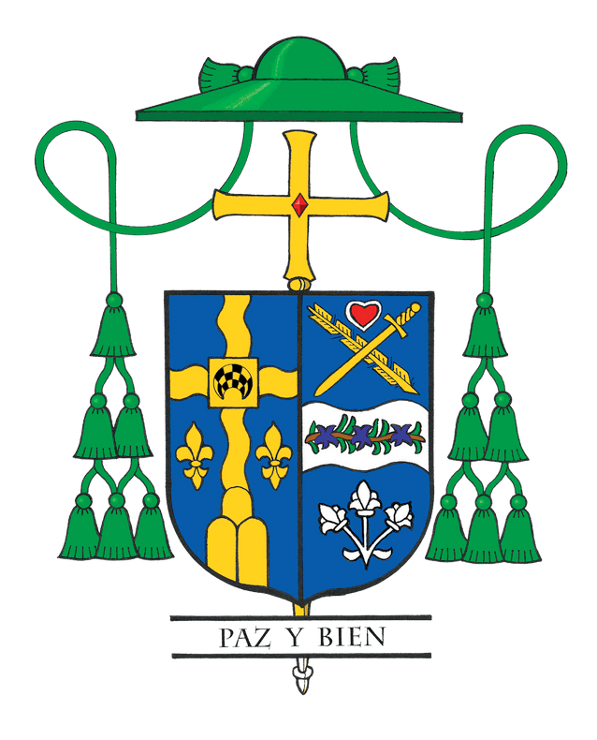
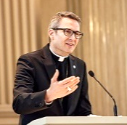
Bishop Hicks’ Column
November 2025

“I Have Loved You” — A Gift from the Holy Father

The wait is over! After just five months of being elected, Pope Leo XIV has speedily penned and shared with us his first Apostolic Exhortation, Dilexi Te (“I Have Loved You”). It radiates the heart of Jesus and reminds us that love for Christ and love for the poor are inseparable. The Holy Father teaches that when we draw close to those who are weak, forgotten, or struggling, we meet Christ himself. It is not only an invitation to charity; it is a call to conversion.
In last month’s column, I invited everyone to read my pastoral letter MAKE! which lays out our diocesan vision for evangelization. If you have not yet done so, I encourage you to take some quiet time to read and pray with it, and now to also read Dilexi Te. These two letters, the Holy Father’s and ours, speak to one another with one voice: a call to be a Church that listens, serves, and brings the love of Christ into action.
Some may think this theme of love for the poor is simply a continuation of Pope Francis and something that only Francis and Leo share in common. However, Pope Leo shows in a scholarly and deeply pastoral way that love for the poor has always been at the very heart of the Church. Throughout Dilexi Te he grounds this teaching in Scripture from the Old and New Testaments and draws upon the wisdom of the Early Church Fathers, the lives of the saints, and the witness of countless religious orders and popular movements. He even highlights how Saint John Paul II and Pope Benedict XVI carried forward this same conviction in their own teaching. Far from being a new idea, Pope Leo reminds us that this is part of the Church’s unbroken tradition, one that the world urgently needs to hear again today.
Reading Dilexi Te moved me deeply. It reminded me that when we share life with the poor, they evangelize us. During my years serving in El Salvador at a home for orphaned and abandoned children, I remember when a donation allowed us to buy doughnuts for all 525 children. We ran out before the adult staff could have any, including me. Then a little boy approached and offered me two thirds of his doughnut. I said, “That’s generous, but give me one third and keep two thirds.” He replied, “No, Padre, you’re bigger and probably hungrier, you get more.” That small act of love preached the Gospel better than any homily.
I was struck by Pope Leo’s reminder that poverty is not only material. There is also a spiritual poverty, an emptiness and isolation that affects many, especially in our own country. He warns that this kind of poverty can be even more dangerous because it hides behind comfort or distraction. This insight challenges us to see the poor not only as those who lack food or shelter but also as those who hunger for meaning, mercy, and belonging. Our call is to reach both kinds of poverty with the same love of Christ.
Not long ago, I visited a parish food pantry where volunteers gathered to pray before they served. It was not simply about groceries; it was catechesis, evangelization, and faith in action all at once. One volunteer said, “Bishop, we try to do more than give out donations. We are trying to share God’s love and see the face of Christ in everyone we serve.” That is Dilexi Te come to life. When love meets action, we encounter Christ, and transformation happens.
May Dilexi Te be a roadmap for a Church that truly believes what it proclaims: that Christ’s love is most visible when we serve, listen, and walk with the poor. In every act of mercy and every parish outreach, may we turn faith into action and reveal the love that Pope Leo describes so powerfully. And may we, as disciples here in the Diocese of Joliet, make that love visible in our words, our witness, and our works every single day.

