Ford-Iroquois Deanery
Presents
STEP JOYFULLY INTO SPRING
Thursday, June 6, 2024
9:00 am
Immaculate Conception
Secor Street
Gilman, IL 60938
Celebrating
Mass
Father Sebahar Scholarship Recipient
Installation of Officers
Women of the Year
35th Ordination of Father Mike Powell
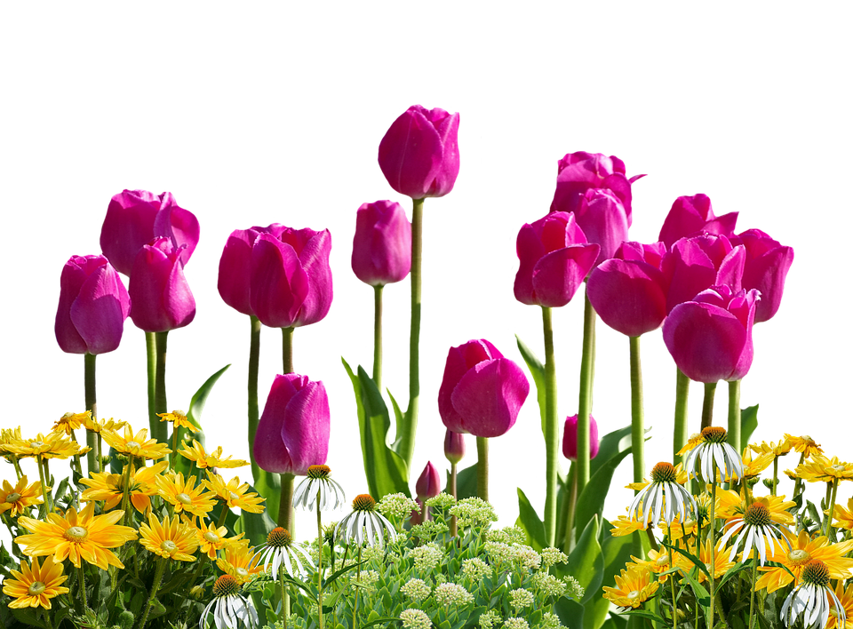
Rsvp – Debbie Krones, debkrones@gmail.com, 815-228-2924

