Together we have
hope in the lord

so. Will - Grundy deanery

spring institute
an evening of fellowship
date: May 22, 2024
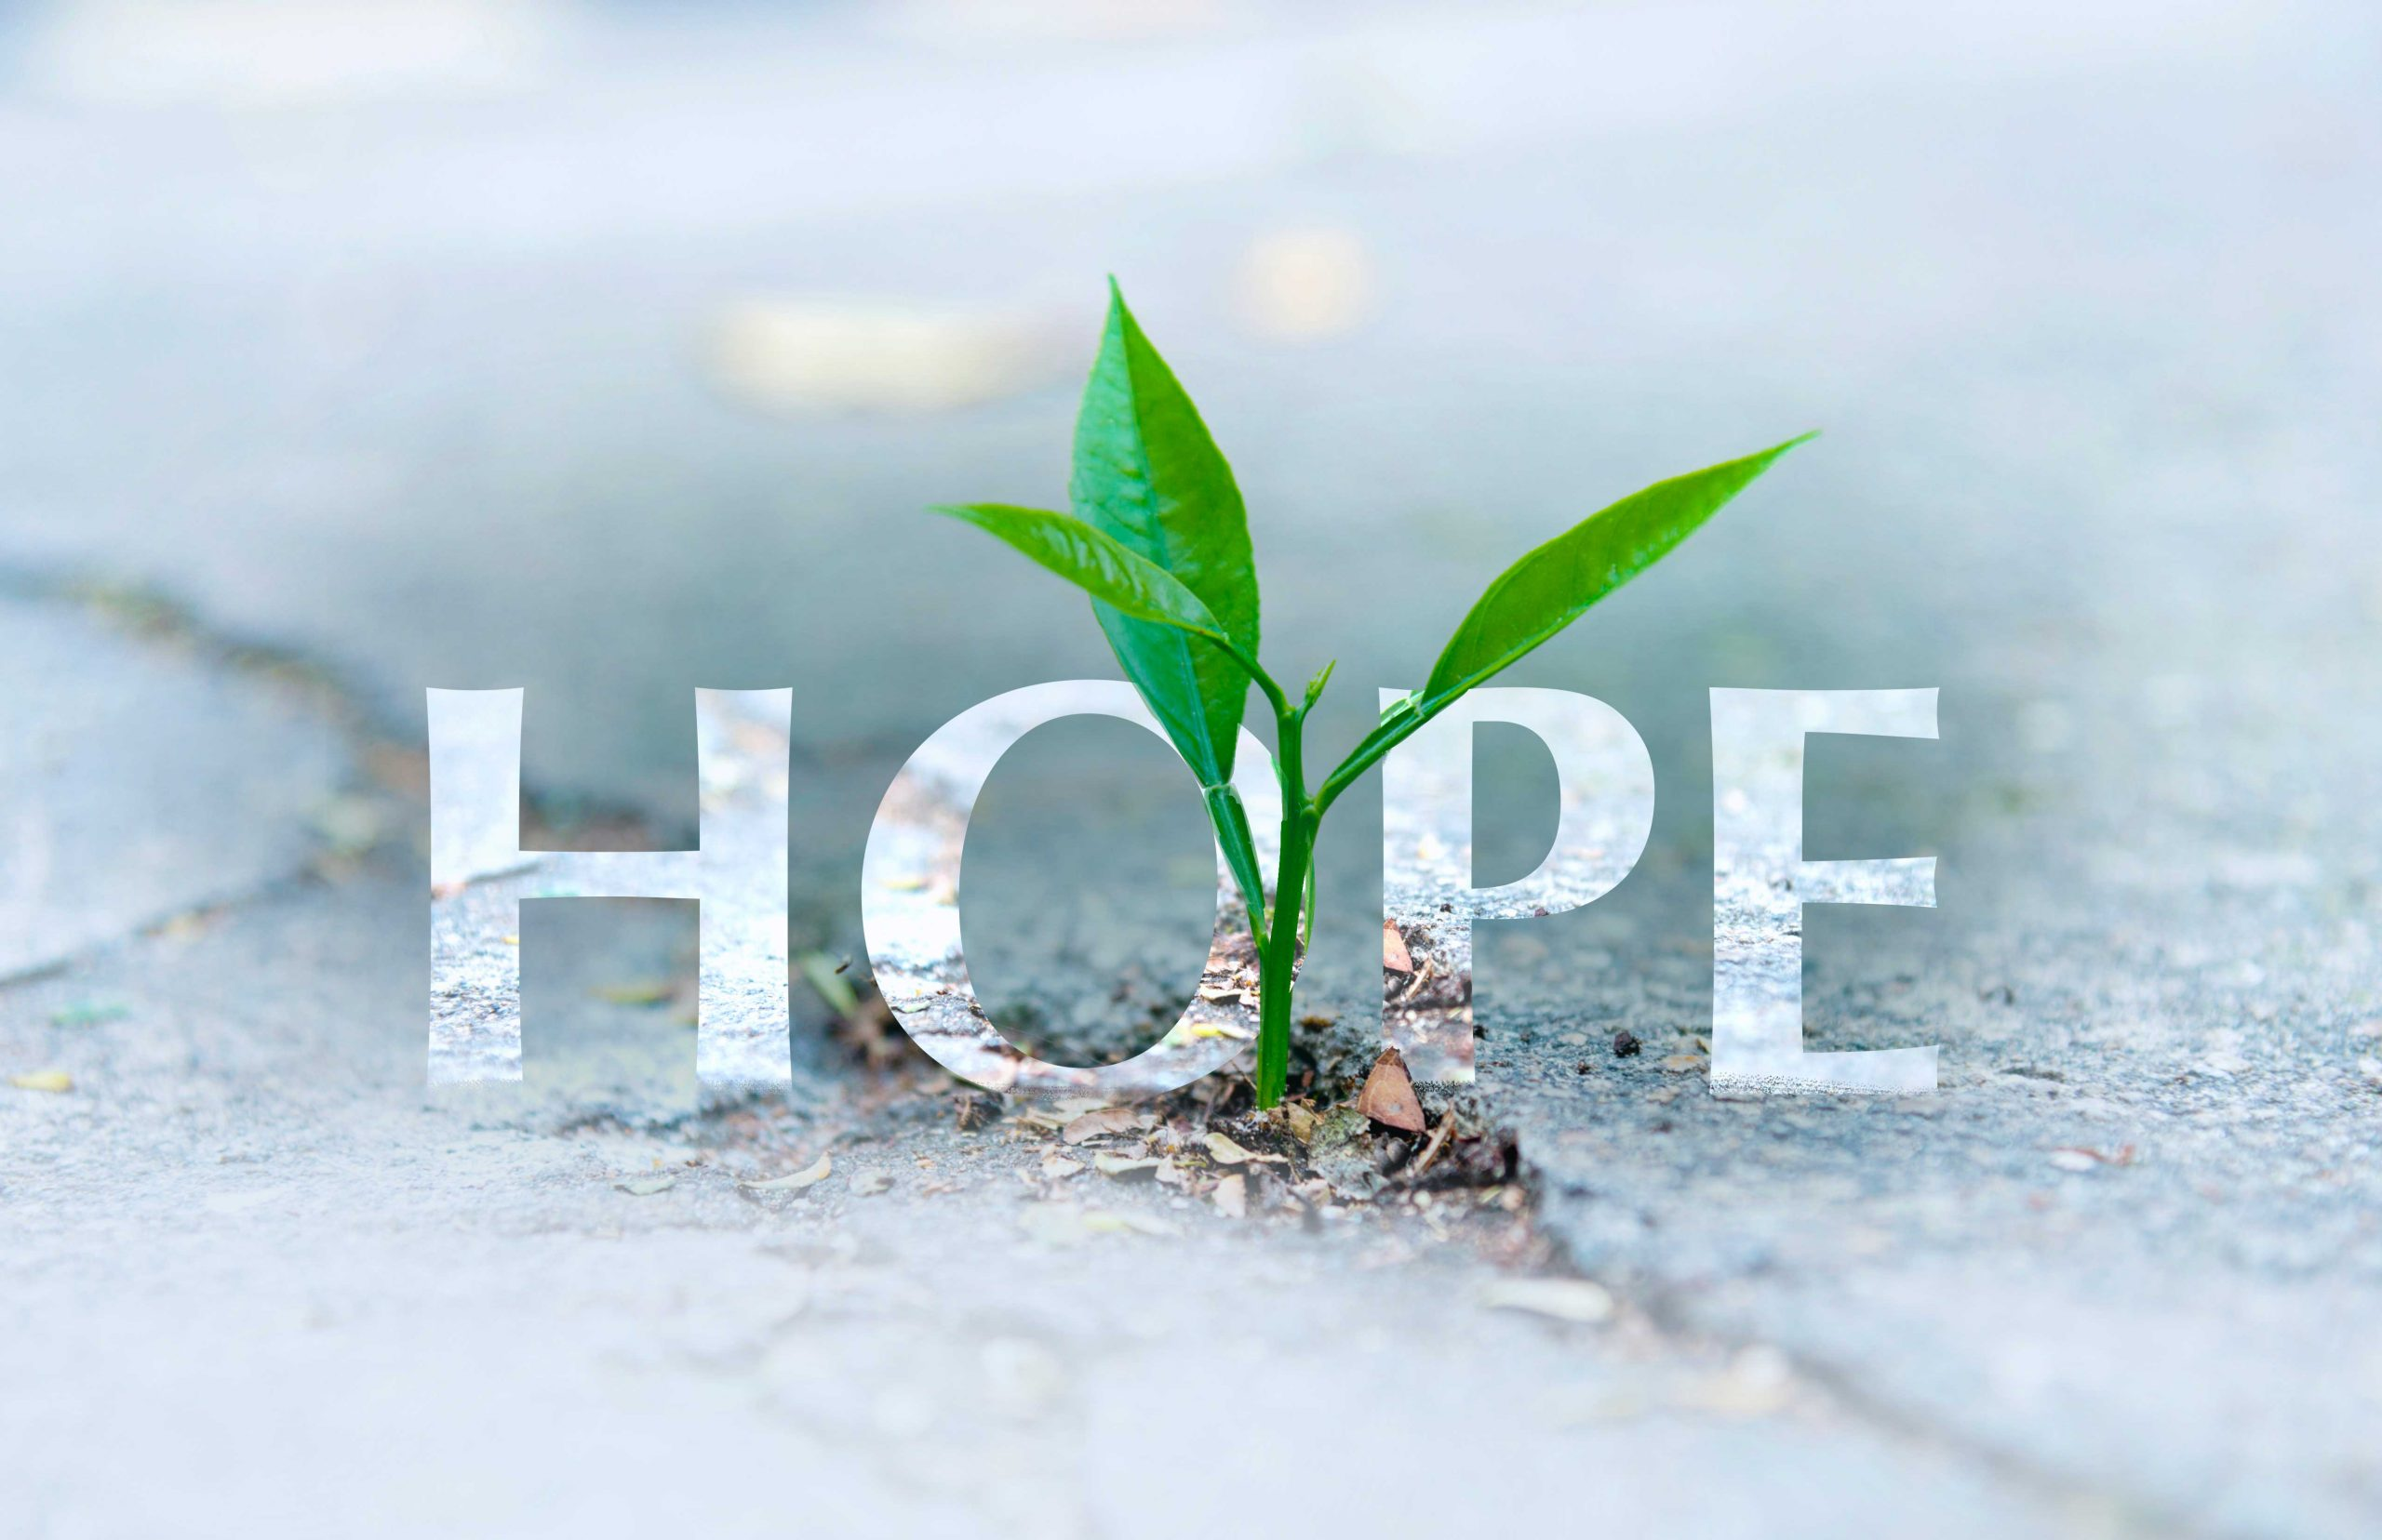
Time: Registration 5:30 pm
Mass 6:00 pm
(dinner and meeting to follow)
celebrant: father sebastian gargol
St. Rose of Lima Catholic Church
(sign in table will be in school foyer)
634 S. Kankakee St., Wilmington, Il.
RSVP: May 8, 2024
Tickets are $20.00 per person. Please mail attendance number and one check from each CCW written to South Will Grundy Deanery mail to
Ann Norkus 19910 Normandy Lane, Mokena, Il. 60448

for more information contact: Laura rusiniak, 630.302.2681

